CLOUD SEEDING
Cloud seeding is a type of weather modification that aims to change the amount or type of precipitation that falls from clouds by dispersing substances into the air that serve as cloud condensation or ice nuclei, which alter the microphysical processes within the cloud. The usual intent is to increase precipitation (rain or snow), but hail and fog suppression are also widely practiced in airports where harsh weather conditions are experienced.
Cloud seeding also occurs due to ice nucleators in nature, most of which are bacterial in origin
Process
The most common chemicals used for cloud seeding include silver iodide, potassium iodide and dry ice (solid carbon dioxide). Liquid propane, which expands into a gas, has also been used. This can produce ice crystals at higher temperatures than silver iodide. After promising research, the use of hygroscopic materials, such as table salt, is becoming more popular.
When cloud seeding, increased snowfall takes place when temperatures within the clouds are between −4 and 19 °F (−20 and −7 °C).Introduction of a substance such as silver iodide, which has a crystalline structure similar to that of ice, will induce freezing nucleation.
In mid-altitude clouds, the usual seeding strategy has been based on the fact that the equilibrium vapor pressure is lower over ice than over water. The formation of ice particles in supercooled clouds allows those particles to grow at the expense of liquid droplets. If sufficient growth takes place, the particles become heavy enough to fall as precipitation from clouds that otherwise would produce no precipitation. This process is known as "static" seeding.
Seeding of warm-season or tropical cumulonimbus (convective) clouds seeks to exploit the latent heat released by freezing. This strategy of "dynamic" seeding assumes that the additional latent heat adds buoyancy, strengthens updrafts, ensures more low-level convergence, and ultimately causes rapid growth of properly selected clouds.[citation needed]
Cloud seeding chemicals may be dispersed by aircraft or by dispersion devices located on the ground (generators or canisters fired from anti-aircraft guns or rockets). For release by aircraft, silver iodide flares are ignited and dispersed as an aircraft flies through the inflow of a cloud. When released by devices on the ground, the fine particles are carried downwind and upward by air currents after release.
An electronic mechanism was tested in 2010, when infrared laser pulses were directed to the air above Berlin by researchers from the University of Geneva.The experimenters posited that the pulses would encourage atmospheric sulfur dioxide and nitrogen dioxide to form particles that would then act as seeds .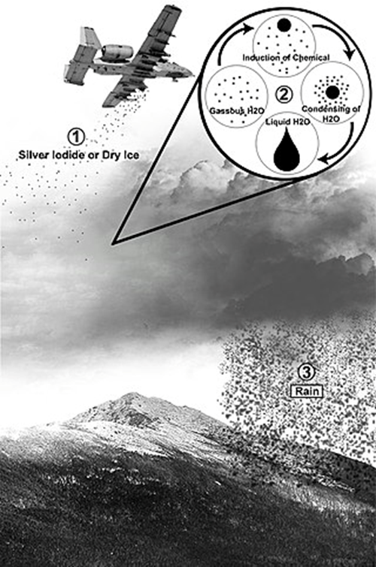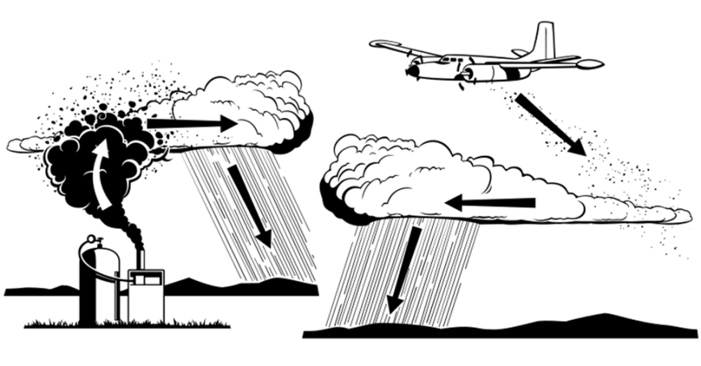

RAINWATER HARVESTATION
Rainwater harvesting is the accumulation and storage of rainwater for reuse on-site, rather than allowing it to run off. Rainwater can be collected from rivers or roofs, and in many places, the water collected is redirected to a deep pit (well, shaft, or borehole), aquifer, a reservoir with percolation, or collected from dew or fog with nets or other tools. Its uses include water for gardens, livestock, irrigation, domestic use with proper treatment, indoor heating for houses, etc. The harvested water can also be used as drinking water, longer-term storage, and for other purposes such as groundwater recharge.
Rainwater harvesting is one of the simplest and oldest methods of self-supply of water for households usually financed by the user
Inverted Umbrella Rain Harvestation System is designed to collect rain water
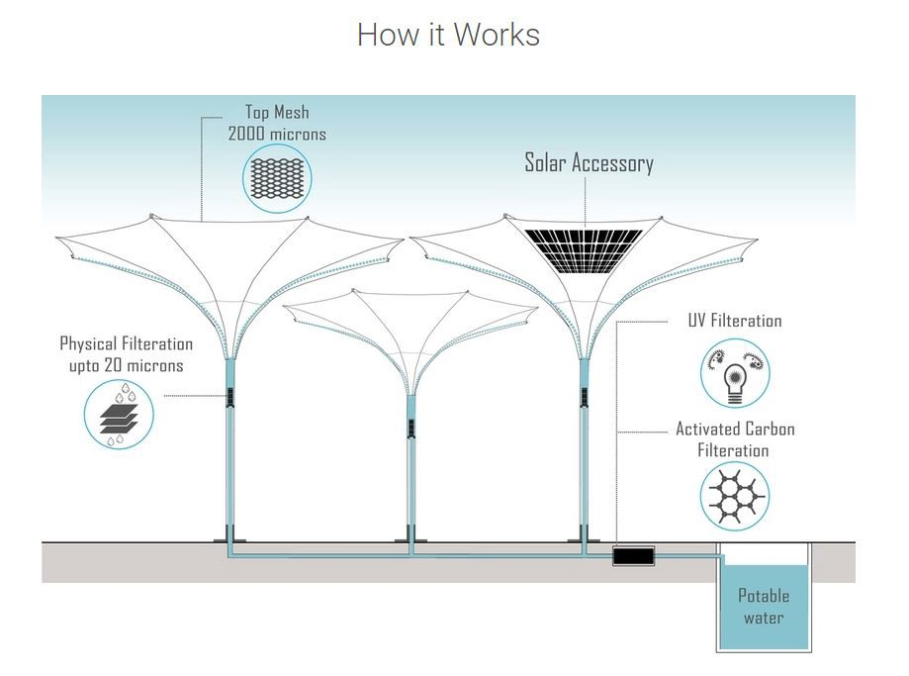

Vast area is being covered by solar PV panels every year in all parts of the world. Solar panels can also be used for harvesting most of the rain water falling on them and drinking quality water, free from bacteria and suspended matter, can be generated by simple filtration and disinfection processes as rain water is very low in salinity
Wells -Rain water collection in the already dug wells found to be highly effective in the bringing ground water level up in India.
Surface runoff harvesting- In urban area rainwater flows away as surface runoff. This runoff could be caught and used for recharging aquifers by adopting appropriate methods.
Rooftop rainwater harvesting- It is a system of catching rainwater where it falls. In rooftop harvesting, the roof becomes the catchments, and the rainwater is collected from the roof of the house/building. It can either be stored in a tank or diverted to artificial recharge system. This method is less expensive and very effective and if implemented properly helps in augmenting the groundwater level of the area.

FLOOD
Floods are caused by many factors or a combination of any of these generally prolonged heavy rainfall (locally concentrated or throughout a catchment area), highly accelerated snowmelt, severe winds over water, unusual high tides, tsunamis, or failure of dams, levees, retention ponds, or other structures that retained the water. Flooding can be exacerbated by increased amounts of impervious surface or by other natural hazards such as wildfires, which reduce the supply of vegetation that can absorb rainfall.
Periodic floods occur on many rivers, forming a surrounding region known as the flood plain.
Forecasting Flood
This method used for remote sensing the disasters such as floods, earthquakes, and explosions is Multi temporal visualization of Synthetic Aperture Radar (SAR) images. These images helps in providing immediate first aid to the people. The process also helps in identifying the permanent waters and other classes by combined composition of pre-disaster and post-disaster images into a color image for better identity
Methods of Flood Management
Some methods of flood control have been practiced since ancient times.[1] These methods include planting vegetation to retain extra water, terracing hillsides to slow flow downhill, and the construction of floodways (man-made channels to divert floodwater).[1] Other techniques include the construction of levees, lakes, dams, reservoirs,[1] retention ponds to hold extra water during times of flooding.

Dams
Many dams and their associated reservoirs are designed completely or partially to aid in flood protection and control. Many large dams have flood-control reservations in which the level of a reservoir must be kept below a certain elevation before the onset of the rainy/summer melt season to allow a certain amount of space in which floodwaters can fill. Other beneficial uses of dam created reservoirs include hydroelectric power generation, water conservation, and recreation. Reservoir and dam construction and design is based upon standards, typically set out by the government. In the United States, dam and reservoir design is regulated by the US Army Corps of Engineers (USACE). Design of a dam and reservoir follows guidelines set by the USACE and covers topics such as design flow rates in consideration to meteorological, topographic, streamflow, and soil data for the watershed above the structure.The term dry dam refers to a dam that serves purely for flood control without any conservation storage (e.g. Mount Morris Dam, Seven Oaks Dam).
Diversion canals (Flood control channel)
Floods can be controlled by redirecting excess water to purpose-built canals or floodways, which in turn divert the water to temporary holding ponds or other bodies of water where there is a lower risk or impact to flooding. Examples of flood control channels include the Red River Floodway that protects the City of Winnipeg (Canada).
Floodplains and Groundwater Replenishment
Excess water can be used for groundwater replenishment by diversion onto land that can absorb the water. This technique can reduce the impact of later droughts by using the ground as a natural reservoir. It is being used in California, where orchards and vineyards can be flooded without damaging crops,or in other places wilderness areas have been re-engineered to act as floodplains.[5]
River Defences
In many countries, rivers are prone to floods and are often carefully managed. Defenses such as levees, bunds, reservoirs, and weirs are used to prevent rivers from bursting their banks.
A weir, also known as a lowhead dam, is most often used to create millponds, but on the Humber River in Toronto, a weir was built near Raymore Drive to prevent a recurrence of the flood damage caused by Hurricane Hazel in October 1954.
Coastal defenses
Coastal flooding has been addressed with coastal defences, such as sea walls, beach nourishment, and barrier islands. Tide gates are used in conjunction with dykes and culverts. They can be placed at the mouth of streams or small rivers, where an estuary begins or where tributary streams, or drainage ditches connect to sloughs. Tide gates close during incoming tides to prevent tidal waters from moving upland, and open during outgoing tides to allow waters to drain out via the culvert and into the estuary side of the dike. The opening and closing of the gates is driven by a difference in water level on either side of the gate.
Self-closing flood barrier
The self-closing flood barrier (SCFB) is a flood defense system designed to protect people and property from inland waterway floods caused by heavy rainfall, gales or rapid melting snow.[citation needed] The SCFB can be built to protect residential properties and whole communities, as well as industrial or other strategic areas. The barrier system is constantly ready to deploy in a flood situation, it can be installed in any length and uses the rising flood water to deploy.
Temporary perimeter barriers
When permanent defenses fail, emergency measures such as sandbags or inflatable impermeable sacks are used.
In 1988, a method of using water to control flooding was discovered. This was accomplished by containing 2 parallel tubes within a third outer tube. When filled, this structure formed a non-rolling wall of water that can control 80 percent of its height in external water depth, with dry ground behind it. Eight foot tall water filled barriers were used to surround Fort Calhoun Nuclear Generating Station during the 2011 Missouri River Flooding. Instead of trucking in sandbag material for a flood, stacking it, then trucking it out to a hazmat disposal site, flood control can be accomplished by using the on site water. However, these are not fool proof. A 8 feet (2.4 m) high 2,000 feet (610 m) long water filled rubber flood berm that surrounded portions of the plant was punctured by a skid-steer loader and it collapsed flooding a portion of the facility.[7]
In 1999, a group of Norwegian engineers patented a transportable, removable, and reusable flood barrier which uses the water's weight against itself. This removable flood panels protect cities and public utilities.[8][promotional language]
Other solutions, such as HydroSack, are polypropylene exteriors with wood pulp within, though they are one-time use.[9]
Hazard Reduction through Strategic Retreat
One way of reducing the damage caused by flooding is to remove buildings from flood-prone areas, leaving them as parks or returning them to wilderness. Floodplain buyout programs have been operated in places like New Jersey (both before and after Hurricane Sandy).
In the United States, FEMA produces flood insurance rate maps that identify areas of future risk, enabling local governments to apply zoning regulations to prevent or minimize property damage.
Hazard reduction through improving Resilience
Buildings and other urban infrastructure can be designed so that even if a flood does happen, the city can recover quickly and costs are minimized. For example, homes can be put on stilts (poles).Electrical and HVAC equipment can be put on the roof instead of in the basement, and subway entrances and tunnels can have built-in movable water barriers. New York City began a substantial effort to plan and build for flood resilience after Hurricane Sandy.
WHAT IS CHANNELIZATION?
Channelization is a method of river engineering that widens or deepens rivers to increase the capacity for flow volume at specific sections of the river. As a result, during flood times watercourses can move more efficiently and facilitate more water, which results in less damage to banks. Furthermore, channelization can provide erosion control and the rehabilitation of watercourses. Despite these benefits, channelization may cause damage further downstream where efforts to widen or deepen the river were not undertaken.
WHAT IS WATER COURSE IMPROVEMENT
The watercourse improvement / renovation consists of complete demolishing of community channel and its rebuilding/re-aligning according to the engineering design to increase conveyance efficiency by reducing seepage, evaporation, and operational losses.
Looming water scarcity could be curtailed with intelligent water losses control. Present study was designed to assess the relative effect of watercourse lining in prospect of seepage minimization. Qualitative as well as quantitative analysis was undertaken using water conveyance efficiency, annual water saving, increase in cropping intensities, time and land saving along with labor saving indictors over Gadeji minor in Sindh, Pakistan. Primary data was collected from field measurements while secondary data was gathered from National Program for Improvement of Watercourses (NPIW), Irrigation Department, personal interviews and site survey. The analysis revealed that lining of 30% initial portion of watercourses resulted average annual water saving of 10.32 hectare-m. Similarly, the cropping intensity increased 15% in Rabi and 14% in Kharif seasons. Crop yield increased by 17% for wheat crop, 14% for cotton crop, 12% for sugarcane, 17% for chilies, 11% for onion crop and 20% for rice crop after lining the selected watercourses. Thus, it is concluded that watercourse lining has noticeable effect for seepage control which yielded a significant water saving. In future, economic viability of watercourse lining may be assessed for obtaining optimum benefits.
DROUGHT MANAGEMENT
Drought is a natural hazard, it has a slow onset, and it evolves over months or even years. It may affect a large region and causes little structural damage. The impacts of drought can be reduced through preparedness and mitigation.
The components of a drought preparedness and mitigation plan are the following:
▪ Prediction
▪ Monitoring
▪ Impact assessment
▪ Response.
Prediction can benefit from climate studies which use coupled ocean/atmosphere models, survey of snow packs, anomalous circulation patterns in the ocean and atmosphere, soil moisture, assimilation of remotely sensed data into numerical prediction models, and knowledge of stored water available for domestic, stock, and irrigation uses.
Monitoring exists in countries which use ground-based information such as rainfall, weather, crop conditions and water availability. Satellite observations complement data collected by ground systems. Satellites are necessary for the provision of synoptic, wide-area coverage.
Impact assessment is carried out on the basis of land-use type, persistence of stressed conditions, demographics and existing infrastructure, intensity and areal extent, and its effect on agricultural yield, public health, water quantity and quality, and building subsidence.
Response includes improved drought monitoring, better water and crop management, augmentation of water supplies with groundwater, increased public awareness and education, intensified watershed and local planning, reduction in water demand, and water conservation.
Strategies for drought protection, mitigation or relief include:
Dams – many dams and their associated reservoirs supply additional water in times of drought.
Check dams are temporary structures constructed with locally available materials. Types of check dams are the brush-wood dam, the loose-rock dam and the woven-wire dam.
Cloud Seeding – a form of intentional weather modification to induce rainfall. Desalination – use of sea water for irrigation or consumption.
Land use – Carefully planned crop rotation, tillage practices , terrace cropping, and contoured cropping can help to minimize erosion and allow farmers to plant less water-dependent crops in drier years.
Outdoor water-use restriction – Regulating the use of sprinklers, hoses or buckets on outdoor plants, filling pools, and other water-intensive home maintenance tasks. Xeriscaping yards can significantly reduce unnecessary water use by residents of towns and cities.
Rainwater harvesting – Collection and storage of rainwater from roofs or other suitable catchments.
Recycled water – Former wastewater (sewage) that has been treated and purified for reuse.
Transvasement – Building canals or redirecting rivers as massive attempts at irrigation in drought-prone areas
Percolation pond- store water for livestock and recharge the groundwater. They are constructed by excavating a depression to form a small reservoir, or by constructing an embankment in a natural ravine or gully to form an impoundment
Contour bunds, trenches and stone walls - prevent soil erosion and obstruct the flow of runoff. The retained water increases soil moisture and recharges the groundwater.
Wind break Windbreaks are such structures which break the wind-flow and reduce wind speed
Shelterbelts are rows of trees or shrubs planted for protection of crop against wind.
GROUND WATER ZONNING AND SKIMMING WELLS
In today's society the planned management of groundwater resources has played an increasingly greater role. One means of insuring the protection of groundwater quantity and quality is a regional zoning of groundwater resources. Regional zoning means to classify a given region with regard to hydrogeological characteristics and to evaluate and determine the possible use of each zone. The necessary assumption is the appropriate knowledge of geological structure (compiled in a geological map) and of hydrogeological conditions (compiled in a hydrogeological map). The basis for subdivision is a hydrogeological unit distinguished and delineated on the basis of lithological, stratigraphical, structural, and hydrogeological characteristics. It should have its own distinct hydrological system. The hydrogeological region is the basic unit. Regions may be grouped into larger units: hydrogeological provinces and realms. The subdivision of regions into hydrogeological zones, or subzones when applicable, forms the basis for a groundwater development plan
The term SKIMMING WELL is used for any technique employed with an intention to extract relatively freshwater from the upper zone of the fresh-saline aquifer. The types of skimming wells include: the conventional single strainer well, multi-strainers wells, scavenger wells, radial collector wells and dug wells. The skimming wells are low discharge (less than 28 l.p.s.) cluster of wells drawing groundwater from relatively shallow depth. Skimming wells are generally designed for irrigation(Saeed et al., 2002a) or drinking water supply (Rao et al 2006, 2007) purposes.
Rates of pumping of saline groundwater is a crucial decision variable, especially when sustained pumping have to be done on a long term basis. Unregulated pumping often results in up-coning phenomena resulting in increased salinity of pumped groundwater. Therefore regulated pumping along the planning horizon must be carefully implemented such that relatively least saline water is skimmed from upper unconfined aquifer system. Groundwater management models embedding numerical flow and transport (salt) models with in simulation-optimisation frameworks are often employed for this purpose (Rao et al 2007)
WHAT IS LASER LAND LEVELING?
Laser land leveling is essentially a water-saving technology as it uses scarce groundwater optimally by ensuring even coverage. Compared to traditionally leveled land, a laser leveled farm minimizes run-off and water-logging ensuring that farmers use just as much water they need in the best possible way.
CROPPING SYSTEMS
Monocropping: Example Planting Wheat year after year in the same field. Monocropping is when the field is used to grow only one crop season after season.but it is difficult to maintain cover on the soil; it encourages pests, diseases and weeds; and it can reduce the soil fertility and damage the soil structure.
Crop Rotation: Example Planting maize one year, and beans the next. Crop Rotation means changing the type of crops grown in the field each season or each year (or changing from crops to fallow).Crop rotation is a key principle of agriculture conservation because it improves the soil structure and fertility, and because it helps control weeds, pests and diseases.
Sequential Cropping: Example- Planting maize in the long rains, then beans during the short rains. Sequential Cropping involves growing two crops in the same field, one after the other in the same year.In some places, the rainy season is long enough to grow two crops: either two main crops, or one main crop followed by a cover crop.Growing Crops two crops may also be possible if there are two rainy seasons, or if there is enough moisture left in the soil to grow a second crop.
Intercropping: Examples- Planting alternating rows of maize and beans, or growing a cover crop in between the cereal rows. Intercropping means growing two or more crops in the same field at the same time.
Mixed Intercropping: Distribution of the seeds of both the crops, or dibbling the seeds without any row arrangement. This process is called mixed intercropping. It is easy to do but makes weeding, fertilization and harvesting difficult. Individual plants may compete with each other because they are too close together.Planting the main crop in rows and then spreading the seeds of the intercrop (such as a cover crop).
Row Intercropping: Planting both the main crop and the intercrop in rows. This is called row intercropping. The rows make weeding and harvesting easier than with mixed intercropping.
Stir Cropping: Example planting alternating strips of maize, soybean and finger millet. Stir Cropping involves planting broad strips of several crops in the field. Each strip is 3–9 m wide. On slopes, the strips can be laid out along the contour to prevent erosion. The next year, the farmer can rotate crops by planting each strip with a different crop.It produces a variety of crops, the legume improves the soil fertility, and rotation helps reduce pest and weed problems.The residues from one strip can be used as soil cover for neighbouring strips.At the same time, strip cropping avoids some of the disadvantages of intercropping: managing the single crop within the strip is easy, and competition between the crops is reduced.
Relay Cropping : Example- Planting maize, then sowing beans between the maize rows four weeks later.Relay Cropping the process of growing one crop, then planting another crop (usually a cover crop) in the same field before harvesting the first. This helps avoid competition between the main crop and the intercrop. It also uses the field for a longer time, since the cover crop usually continues to grow after the main crop is harvested
TYPES OF IRRIGATION SYSTEMS
There are many different types of irrigation systems, depending on how the water is distributed throughout the field. Some common types of irrigation systems include:
Surface irrigation
Water is distributed over and across land by gravity, no mechanical pump involved.
Localized irrigation
Water is distributed under low pressure, through a piped network and applied to each plant.
Drip irrigation
A type of localized irrigation in which drops of water are delivered at or near the root of plants. In this type of irrigation, evaporation and runoff are minimized.
Sprinkler irrigation
Water is distributed by overhead high-pressure sprinklers or guns from a central location in the field or from sprinklers on moving platforms.
Center pivot irrigation
Water is distributed by a system of sprinklers that move on wheeled towers in a circular pattern. This system is common in flat areas of the United States.
Lateral move irrigation
Water is distributed through a series of pipes, each with a wheel and a set of sprinklers, which are rotated either by hand or with a purpose-built mechanism. The sprinklers move a certain distance across the field and then need to have the water hose reconnected for the next distance. This system tends to be less expensive but requires more labor than others.

DESALINIZATION
Desalination is a process that takes away mineral components from saline water. More generally, desalination refers to the removal of salts and minerals from a target substance, as in soil desalination, which is an issue for agriculture.
Saltwater is desalinated to produce water suitable for human consumption or irrigation. The by-product of the desalination process is brine.[3] Desalination is used on many seagoing ships and submarines. Most of the modern interest in desalination is focused on cost-effective provision of fresh water for human use. Along with recycled wastewater, it is one of the few rainfall-independent water sources.
Due to its energy consumption, desalinating sea water is generally more costly than fresh water from rivers or groundwater, water recycling and water conservation. However, these alternatives are not always available and depletion of reserves is a critical problem worldwide.Desalination processes are usually driven by either thermal (in the case of distillation) or electrical (e.g., photovoltaic or wind power) as the primary energy types.
Currently, approximately 1% of the world's population is dependent on desalinated water to meet daily needs, but the UN expects that 14% of the world's population will encounter water scarcity by 2025.Desalination is particularly relevant in dry countries such as Australia, which traditionally have relied on collecting rainfall behind dams for water.
Kuwait produces a higher proportion of its water than any other country, totaling 100% of its water use.
Methods for desalination
• Distillation
o Multi-stage flash distillation (MSF)
o Multiple-effect distillation (MED)
o Vapor-compression (VC)
• Ion exchange
• Membrane processes
o Electrodialysis reversal (EDR)
o Reverse osmosis (RO)
o Nanofiltration (NF)
o Membrane distillation (MD)
o Forward osmosis (FO)
• Freezing desalination
• Geothermal desalination
• Solar desalination
o Solar humidification–dehumidification (HDH)
o Multiple-effect humidification (MEH)
o Seawater greenhouse
• Methane hydrate crystallization
• High grade water recycling
• Wave-powered desalination

